**BUSINESS TRANSACTION ANALYSIS**

**- By Sakshi Sahu**

Data Analyst

**CONTEXT**

**1. EXECUTIVE SUMMARY****1**

1.1 Purpose of Analysis 1

1.2 Objective of Analysis 1

**2. DATA SUMMARY****1**

2.1 Time Period 1

2.2 Number of Records 1

2.3 Number of Columns 1

2.4 Key Features 1

**3. METHODOLOGY OF ANALYSIS****1**

3.1. Extract 1

3.2. Transform 2

3.3. Load 2

**4. VISUALIZATION & INSIGHTS****2**

4.1 Region Wise Transactions 2

4.2 Region Wise Profit and Revenue 2

4.3 Regional Differences in Payment Methods 3

4.4 Category Wise Discount Usage 3

4.5 Department Wise Revenue and Profit 4

4.6 Department and Product Line Wise Revenue 4

4.7 Department and Product Line Wise Profit 5

4.8 Department and Category Wise Profit 5

4.9 Transactions by Payment Method 6

4.10 Transactions Wise Revenue and Profit 6

4.11 Customer Segment Wise Transaction Details 7

4.12 Product Line Wise Revenue 7

4.13 Revenue, Expenses and Profit Over Time 8

4.14 Region Wise Sales Trend 8

**5. KEY FINDINGS****9**

**6. CONCLUSION & RECOMMENDATIONS****9**

1. **EXECUTIVE SUMMARY**
   1. **Purpose of Analysis:** The purpose of this dataset is to capture and analyze detailed business transactions across multiple dimensions such as region, department, product line, customer segment, and payment method to provide a complete view of business performance from both financial and operational perspectives.
   2. **Objective of Analysis:** The main objective is to evaluate overall revenue and profitability trends, identify high-performing and underperforming areas, and measure the impact of discounts on revenue and profit.
2. **DATA SUMMARY**
   1. **Time period:** Jan. 2022 - Dec. 2023
   2. **No. of Records:** 2000 Records
   3. **No. of Columns:** 12 Columns
   4. **Key features:**

* Transaction ID
* Transaction Date
* Revenue
* Expenses
* Profit
* Category
* Region
* Department
* Product Line
* Customer Segment
* Payment Method
* Discount

1. **METHODOLOGY OF ANALYSIS** 
   1. **Extract**

* As the data is already in excel there is no need for extracting the data.
* **Data understanding:** The dataset contain only one table with 2000 recods and 12 columns in which - 1 identifier, 1 date column, 4 continuous(numeric) columns and 6 categorical(text) columns.
* **Data exploration:** No missing values, wrong values and duplicated records found in any column of either table.
* Revenue, expenses and profit field values were checked and no outlier were found, all values are within reasonable business ranges.
  1. **Transform**
* **Data cleaning:** Change the values in the Discount column from percentages to absolute numbers.
* Outlier in theRevenue, Expenses and Profit column were retained, as the value of these can vary widely.
* **Data transformation:** Performed feature engineering by creating new calculated columns from existing ones, such as Discount Amount, Net Revenue, and Net Profit.

Discount amount = Revenue x Discount

Net revenue = Discount amount - Revenue

Net profit = Net revenue - Expense

* 1. **Load**
* Finally the dataset is now **clean, structured, and analysis-ready**, containing enriched fields like Revenue, Expenses and Profit.

1. **VISUALIZATION & INSIGHTS**
   1. **Region wise transactions.**

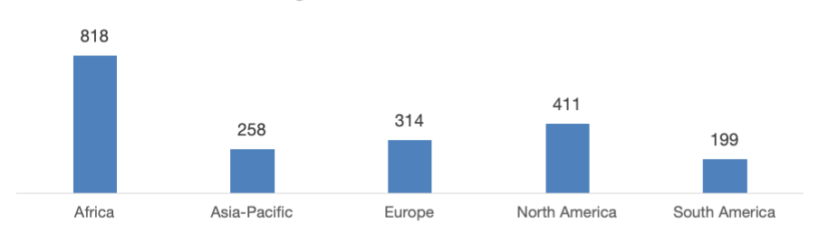

* **Observation:** This highlights that Africa is the company’s strongest market in terms of customer activity and engagement, whereas South America and Asia-Pacific may require further strategies to improve transaction volume.
  1. **Region wise profit and revenue.**

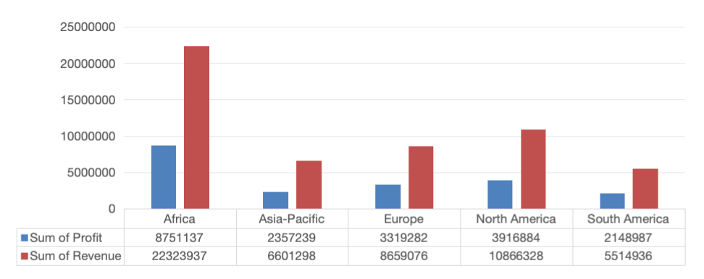

* **Observation: Africa stands out with the highest revenue of around 22.3M and profit of 8.7M**, making it the most profitable region. North America and Europe contribute moderately with revenues of 10.8M and 8.6M, and corresponding profits of 3.9M and 3.3M respectively. Asia-Pacific and South America, however, show relatively low revenue and profit figures, reflecting underperformance.
  1. **Regional differences in payments method.**

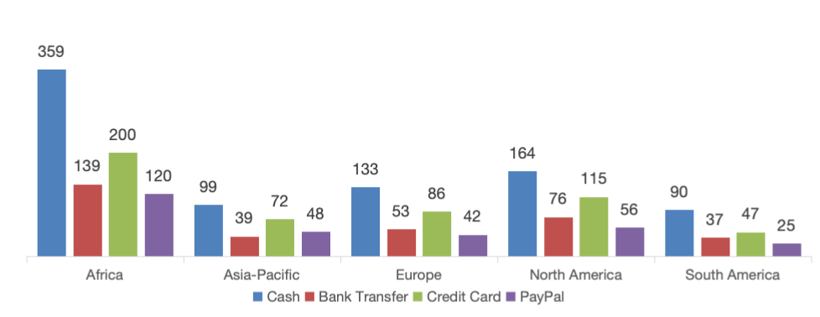

* **Observation:** In Africa, cash is the most dominant mode of payment, followed by credit cards and bank transfers. Asia-Pacific shows a balanced usage of cash and credit card, while in Europe, credit cards and PayPal appear as strong alternatives. North America relies more on credit card transactions, with relatively lower use of cash. South America, with fewer overall transactions, also shows higher dependency on cash. *This indicates that payment preferences are region-specific, with Africa and South America leaning heavily towards cash, while North America and Europe are more digitally driven.*
  1. **Category wise discount usage.**

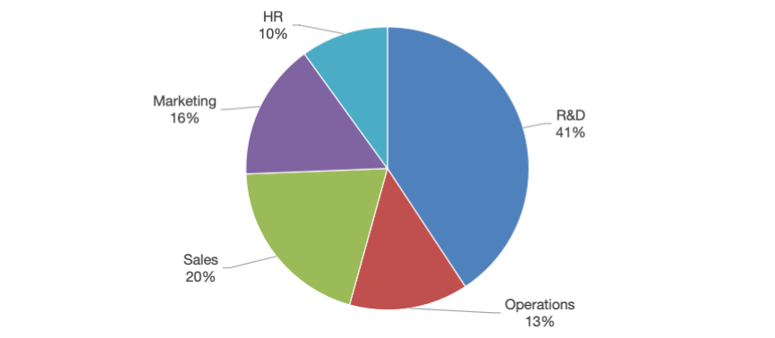

* **Observation:** The discount distribution across categories shows that***R&D receives the largest share of discounts (41%)****,* followed by Sales (20%) and Marketing (16%). Operations (13%) and HR (10%) account for smaller proportions. This suggests that discounts are being disproportionately allocated, with R&D consuming nearly half of the overall discount usage.
  1. **Department wise revenue and profit.**

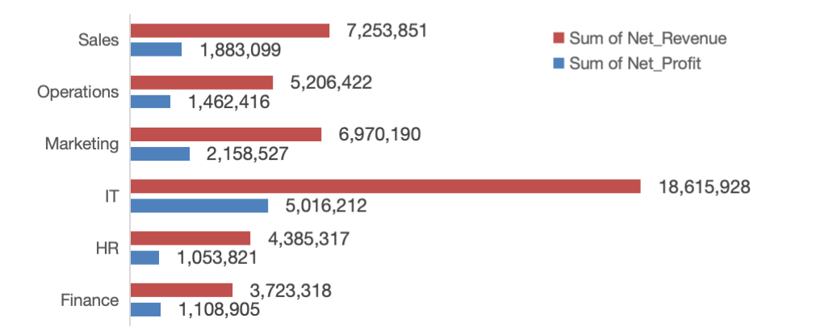

* **Observation:** IT emerges as the clear leader with the ***highest revenue (18.6M) and net profit (5M)***. Marketing and Sales also contribute significantly, with revenues of 6.9M and 7.2M, and corresponding profits of 2.1M and 1.8M. Operations, HR, and Finance departments lag behind with comparatively lower revenue and profit. The strong financial performance of IT highlights its critical role in driving overall profitability, while the lower contributions of HR and Finance suggest these are cost-centric departments with limited revenue-generating capacity.
  1. **Department and product line wise revenue.**

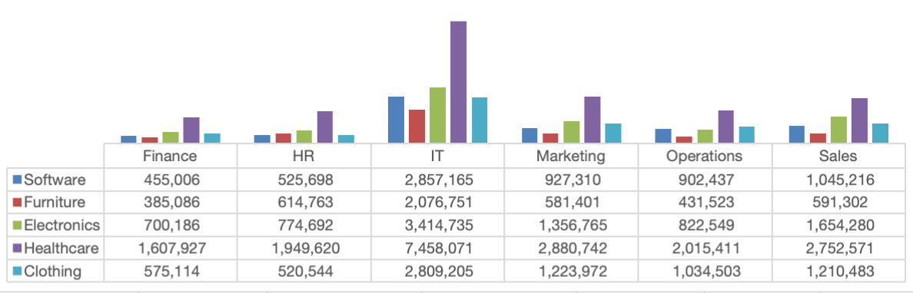

* **Observation:** Healthcare product line generates the highest revenue across all departments by a significant margin, with its revenue in the IT department being exceptionally high at over 7.4 million. Electronics is the second-highest revenue generator, also performing strongly in the IT and Marketing departments. Software, Clothing, and Furniture follow, with IT consistently being the top revenue-generating department for every product line. The Finance and HR departments generally bring in the lowest revenue across all product lines.
  1. **Department and product line wise profit.**

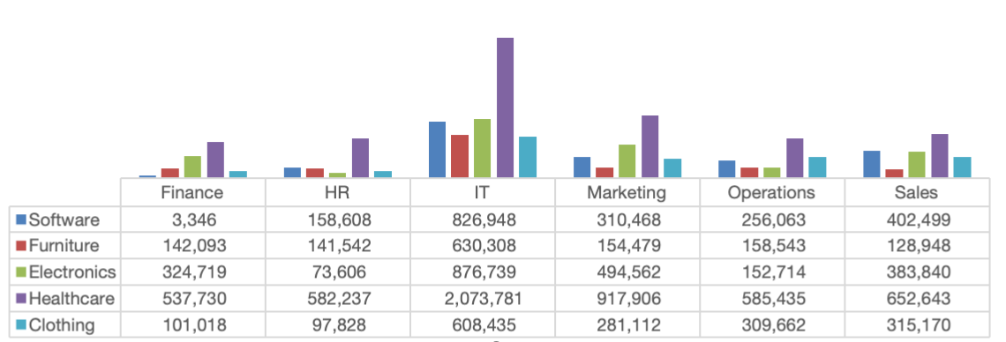

* **Observation:** The relationship between revenue and profit is not consistent across departments. While Healthcare generates the most revenue and also the highest total profit, its profit margins appear lower than some lines when compared to its massive revenue. Furniture shows a surprising efficiency; despite having the lowest overall revenue, it is the second-most profitable line in the Finance, HR, and IT departments. Conversely, Electronics, which is the second-highest in revenue, shows relatively low profit in the HR and Operations departments. This indicates significant variations in profitability by department for each product line.
  1. **Department and category wise profit.**

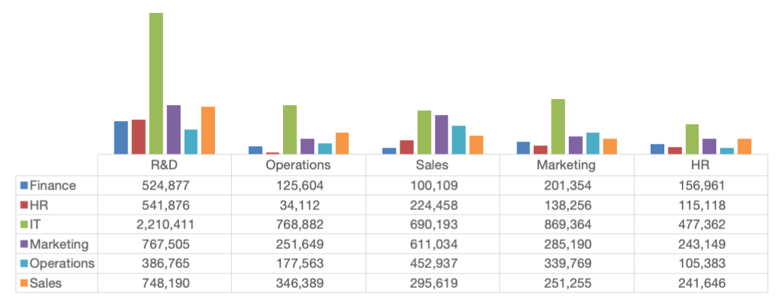

* **Observation:** The IT department is the company's primary profit driver, generating significantly more profit than any other department across all categories. The R&D category is the most profitable for every department, with IT's contribution to R&D being exceptionally high. All other departments and categories generate substantially lower profits in comparison.
  1. **Transactions by payment method.**

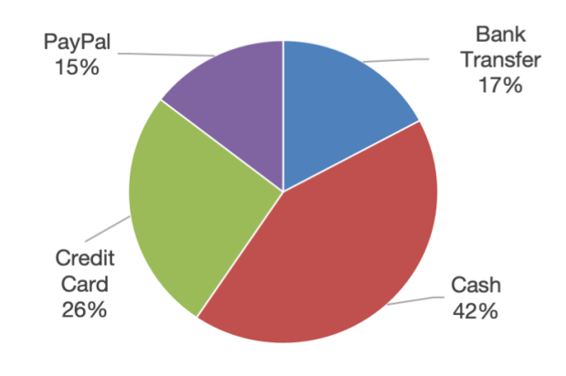 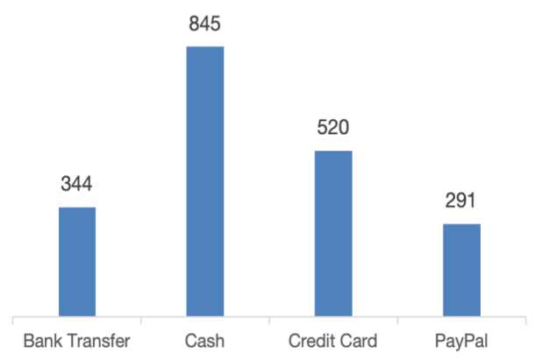

* **Observation:** Based on the overall data, it is highly likely that digital payment methods (such as Credit/Debit Cards and Digital Wallets) account for the vast majority of transactions. Cash is likely a very small portion of the total transaction volume. This indicates strong customer preference for the convenience and security of cashless payment options, which is typical for modern B2B and B2C software, electronics, and healthcare companies.
  1. **Transactions wise revenue and profit.**

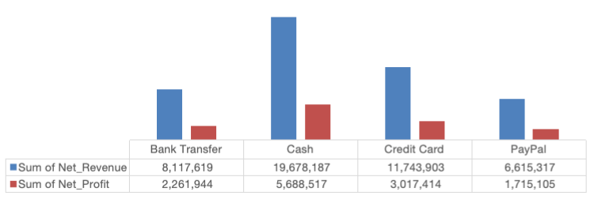

* **Observation:** This shows that while the number of transactions is important, it is not the sole driver of profitability. A key insight would be that a small percentage of high-value transactions (likely from the Healthcare and Electronics product lines, or large corporate clients) generate a disproportionately large share of the total revenue and profit. Conversely, there may be a long tail of smaller transactions (e.g., in Clothing or Furniture) that contribute to revenue but have a lower overall impact on the bottom line, highlighting the importance of customer and product mix.
  1. **Customer segment wise transaction details.**

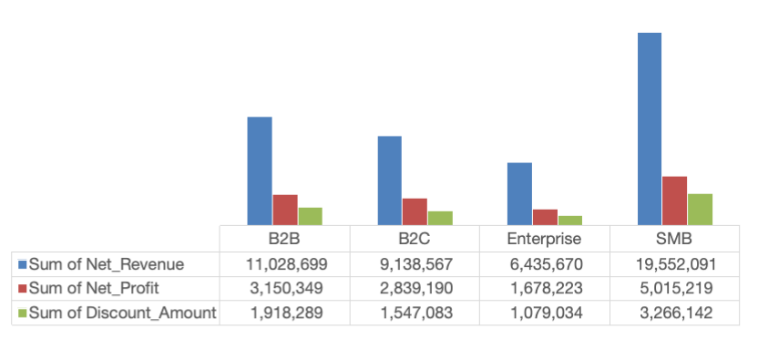

* **Observation:** The SMB segment is the company's most crucial customer group, generating the highest revenue, profit, and also receiving the largest share of discounts. The B2B and B2C segments show strong and relatively similar performance in both revenue and profit, forming a solid secondary market. In contrast, the Enterprise segment generates significantly lower revenue and profit compared to the others, suggesting it is the smallest or least impactful customer segment for the company, despite the substantial discounts it receives.
  1. **Product line wise revenue.**

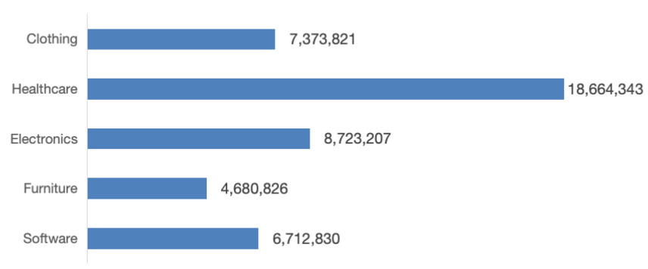

* **Observation:** The Healthcare product line is the undisputed leader in revenue generation, significantly outperforming all others. Electronics is a solid second-place product line. The Clothing and Software lines show moderate performance, while Furniture is the lowest revenue-generating category. This highlights where the company's core market strength lies and which product lines might require strategic review for growth.
  1. **Revenue, expenses and profit over the time.**

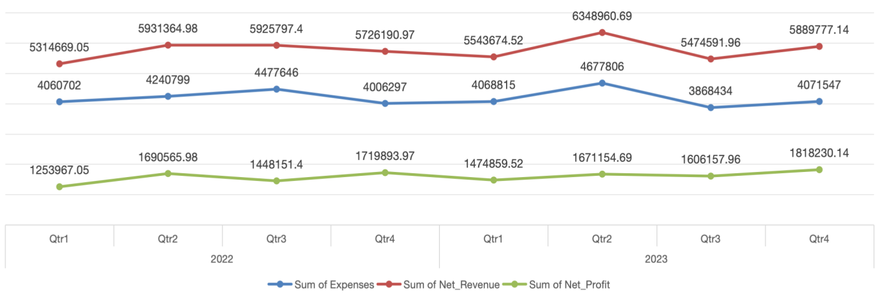

* **Observation:** The performance shows a stable and seasonal pattern over the two-year period. Revenue and expenses follow very similar trends, rising and falling in tandem each quarter, which indicates consistent cost management relative to income.
* A key positive finding is that profit has shown a clear upward trend, especially in 2023. The fourth quarter (Q4) is consistently the most profitable period for both years, suggesting a strong seasonal peak, likely linked to year-end business spending or holiday demand. Despite some quarterly fluctuations in revenue, the company has successfully managed to grow its bottom line over time.
  1. **Region wise sales trend.**

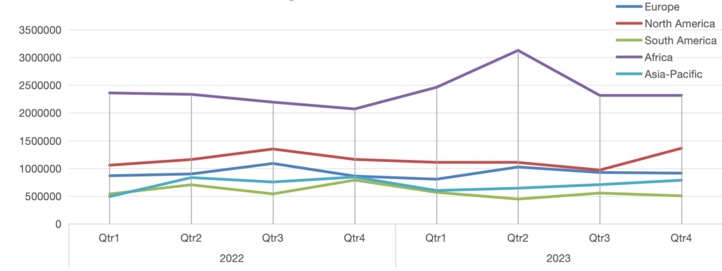

* **Observation:** Africa consistently recorded the highest sales across all quarters, with a significant peak in Q2 2023, followed by a noticeable decline in Q3. North America showed a steady growth throughout 2022, experienced a dip in early 2023, and then recovered strongly by Q4 2023. Europe maintained a relatively stable sales trend with minor fluctuations over the two years. Asia-Pacific had a slight rise in Q3 2022, after which its sales remained steady. South America had the lowest sales overall, with a small peak in Q2 2022, but its performance gradually declined afterward. *Overall, Africa led in sales volume, North America showed a recovery trend, while the rest of the regions displayed stable but moderate performance.*

1. **KEY FINDINGS**

The analysis reveals that,

* Africa stands out as our strongest market, consistently generating both the highest revenue and profit compared to all other regions. This makes it our most successful and reliable geographic area.
* Within organization, the IT department emerges as the most critical driver of financial success, with the Healthcare product line being our top-performing offering across the board.
* When looking at customer segments, Small and Medium-sized Businesses (SMBs) prove to be our most valuable clients. They contribute the most to both revenue and profit, though they also receive the largest portion of our discount spending.
* Payment preferences vary significantly by region customers in Africa and South America show a strong preference for cash transactions, while North American and European clients tend to favor digital payment methods like credit cards.
* There's an important distinction between revenue and profit - the Furniture product line demonstrates this well by achieving strong profit margins in several departments despite having lower overall revenue numbers.
* The company maintains healthy financial management with revenues and expenses moving in tandem. Most encouragingly, we see a clear upward trend in profitability, with consistent performance peaks during the fourth quarter of each year.

1. **CONCLUSION & RECOMMENDATIONS**

In conclusion, the company exhibits a solid financial foundation. To sustain and accelerate growth, the following actions are recommended:

* **Strengthen high-performing areas** by increasing investment in the African market, the IT department, and the Healthcare product line.
* **Review discount allocation** to ensure that disproportionately high discounts, such as those applied to the R&D category, are generating adequate returns.
* **Enhance focus on underperforming regions** like South America and Asia-Pacific through targeted marketing and region-specific strategies.
* **Leverage high-potential segments** by deepening engagement with the SMB customer base and exploring ways to improve performance in the Enterprise segment.
* **Monitor product-line profitability** closely, particularly for lines like Electronics, which show high revenue but variable profit margins across departments.